Frontline Figures - Foot Knights - 7 to 9
(http://www.frontline-figures.com)
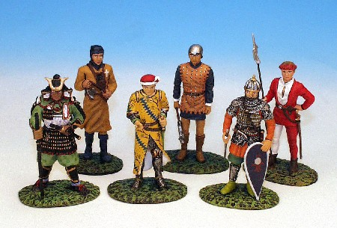  7  Castillian, Slinger, Swiss Axeman, Condottiere, Samurai, Russian Man-at-arms | 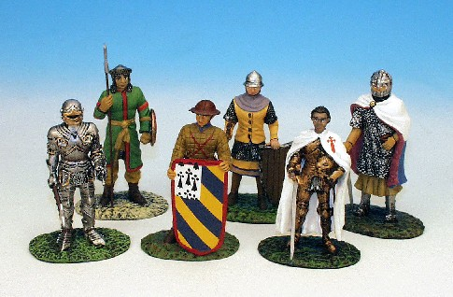  8  DeLuna, French Knight, Pavesier, Byzantin, Saracen, Maximillian knight
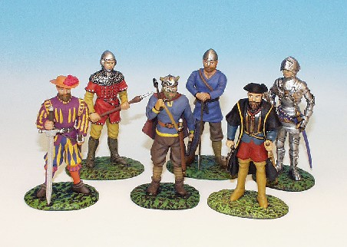
9
Landskecht, Britihs man-at arms, Saxon, Viking, Flammand, Navigator

