Frontline Figures – Warriors of the Ancient World - 7 to 11
(http://www.frontline-figures.com)
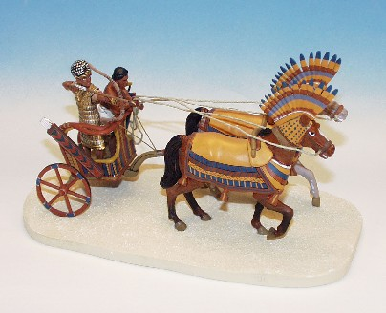  BAC.1  Egyptian Chariot, 2 horses, 2 men - $77 | 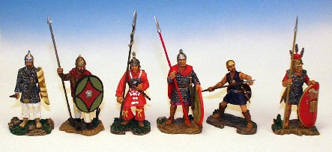  AC.7  Palmyrian Warrior, Marcomannian Warrior, Japanese Warrior, Germanic Volunteer, Lusitan Warrior, Republican Legionary - $77
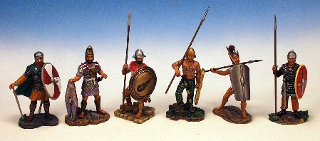  AC.8  Anglo-Saxon Warrior, Guard of the Temple of Jerusalem, Theban Infantry, British Warrior, Samnite Warrior, Cimbri Warrior - $77 | 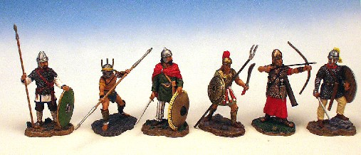  AC.9  Liyian Warrior, Gladiator, Ostgothic Warrior, Sickleman, Roman Archer, Cataphract Warrior- $77
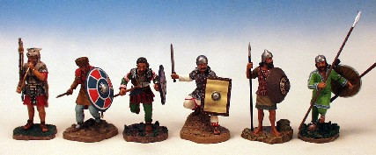  AC.10  Roman Cornicen, Roman Bucelarius, Scythian Warrior, Ghassanid Warrior, Akkadian, Bulgarian Warrior - $77 | 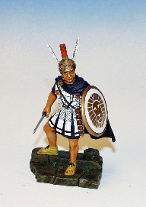  AC.11  Alexander the Great - $15

