Frontline Figures - Mounted Knights - 61 to 64
(http://www.frontline-figures.com)

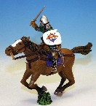  61  Hungarian, XIV | 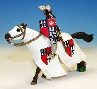  62  Hartman von Kronenberg | 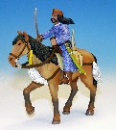  63  Arab light horseman, XI | 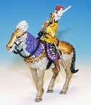  64  Chinese light horseman, XII

