Frontline Figures - Mounted Knights - 41 to 60
(http://www.frontline-figures.com)

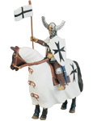  41  Tutonic, XIII | 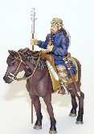  42  Viking, XIII | 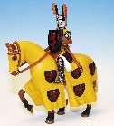  43  Duke of Hohenklinger, XIV | 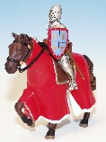  44  Martin de Salinas, XII | 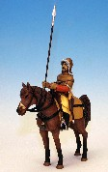  45  Mongol, XII
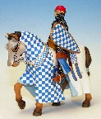  46  Portuguese Knight, XI | 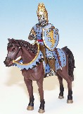47  Gunter Schwarzburg, XIV | 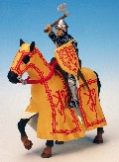48  Robert the Bruce, XII | 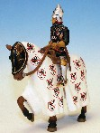49  Duke of Duguesclin, XII | 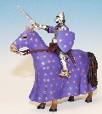  50  Phillip of Aterevido, XIV
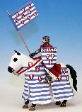51  Jaun De Sitsijt, XII | 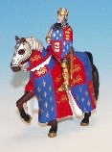52  Edward III, XIII | 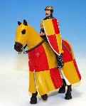  Sold Out  53  Aubrey de Vere, XIII | 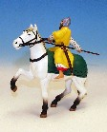  54  Arthur McMuroh,IX | 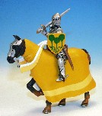  Sold Out  55  Diego Pardo,XV
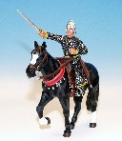  56  El Cid, IX | 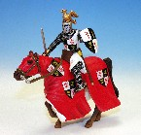  57  Juan de Brabanta, XIII | 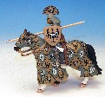  Sold Out  58  King Heinrich, XII | 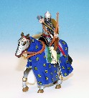  59  Turkish Sipahi, XI | 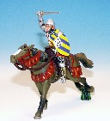  60  Jean de Montaigo, XII

