Frontline Figures - Mounted Knights - 21 to 40
(http://www.frontline-figures.com)

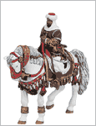  21  Saladin, IX | Sold Out  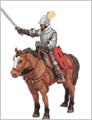  22  Spanish Conquistador, XV | 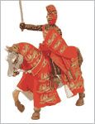  23  Richard the Lionheart, XI | 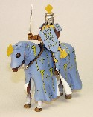  24  Roger de Trumpington, XII | 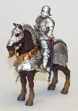  25  German Gothic, XIII
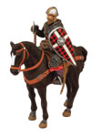  26  Crusader, XII | 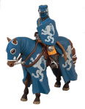  27  Antioch, XII | 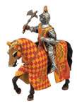  28  Castilian, XIII | 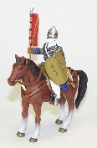  29  Saracen, XII | 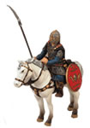  30  Sutton Hoo, IIX
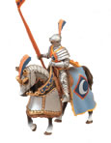  31  French Tournament, XV | 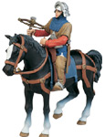  32  Swiss Crossbowman, XIV | 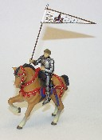  33  Joan of Arc, XIII | 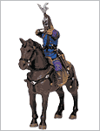  34  Cuman,XII | 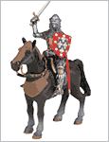  35  French Knight, XII
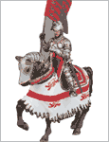  36  Sir John Codrington, XII | Sold Out  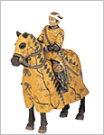  37  Condotiere, XIV | Sold Out  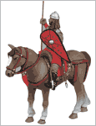  38  Byzantine, XII | Sold Out  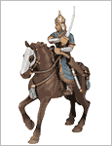  39  Goldern Horde, XII | 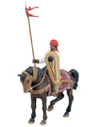  40  Arab, XII

