Frontline Figures - Elite Troops and Police - 13 to 15
(http://www.frontline-figures.com)
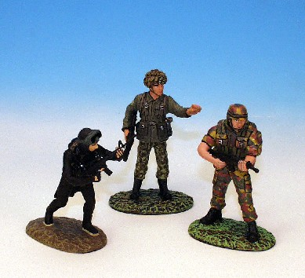  13  SEAL, USA, Paracomando Belgium, Para, Canada | 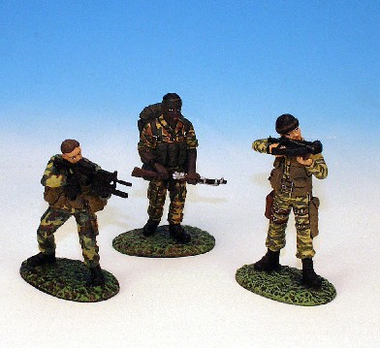  14  Commando, Brazil, Commando, S. Africa, Commando France
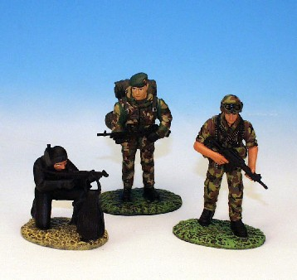
15
Marines, 2. UK. Italy, Israel

