Frontline Figures - Foot Knights - 1 to 6
(http://www.frontline-figures.com)
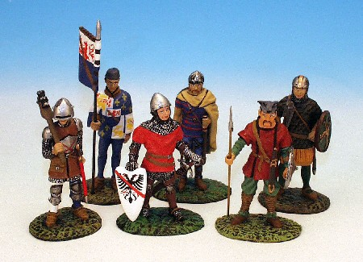  1  Merovinigien, Spanish Axeman, French Nobleman, Gunner, Frank | 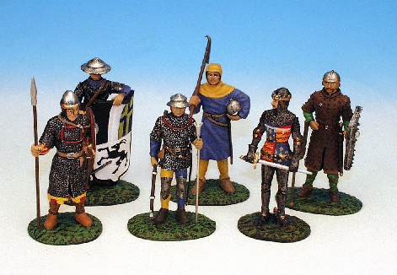  2  Black Prince, Swiss Crossbowman, Aqueber, Norman, Saxon, Peasant
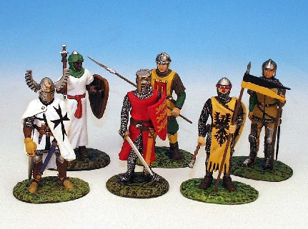  3  Richard the lion heart, French Man at Arms, Arab, German Pikeman, Teutonic Knight, French Bowman | 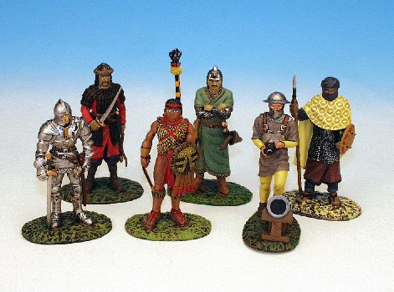  4  Mongol XIII, Mongol Archer, Artilleryman, French Man at Arms, Oymade, Aztec
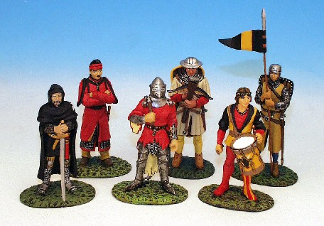  5  Crossbow man, German Pikeman, Hospitaler, Merovinigien VI, Crayfish knight, Chinese Foot, Swiss Drummer | 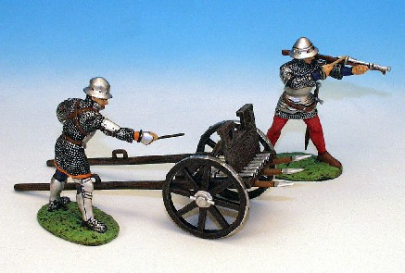  6  Artillery plus 2 gunners

