Frontline Figures – Warriors of the Ancient World - 1 to 6
(http://www.frontline-figures.com)
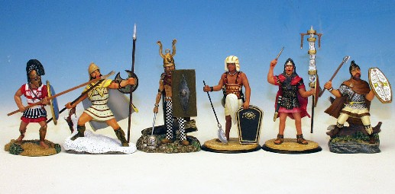  AC.1  Athenian Hoplite, Celt Warrior, Peltasta Tracio, Roman Signifier, Egyptian Warrior, Dacian Warrior - $77 | 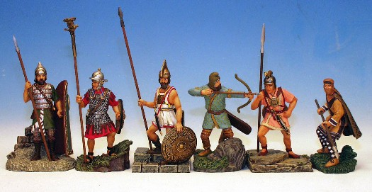  AC.2  Assyrian Infantryman, Roman Aquilifer, Etruscan Warrior, Scythian Warrior, Iberian Warrior, Persian Infantryman - $77
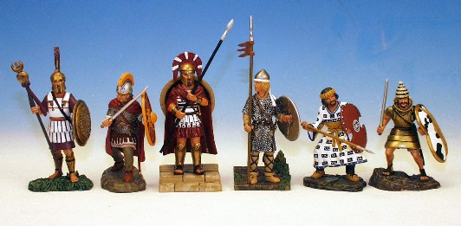  AC.3  Macedonian Standard Bearer, Roman Heavy Infantry, Spartan Hoplite, Frankish Warrior, Achaemenidian, Mycenaean Warrior - $77 | 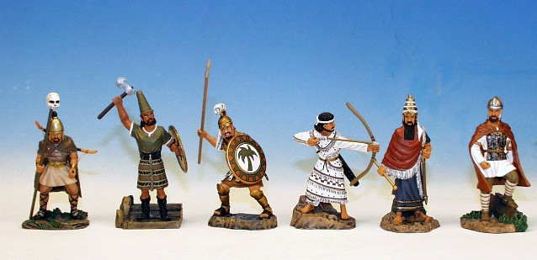  AC.4  Hun Warrior, Hittite Warrior, Carthaginian Warrior, Syrian Archer, Babylonian King, Sarmatian Warrior - $77
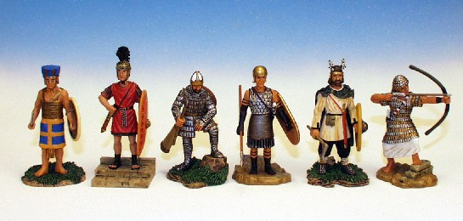  AC.5  Philistine Warrior, Sasanid Officer, Pretorian Guard, Edetan Warrior, Alaman Warrior, Egyptian Armoured Archer - $77 | 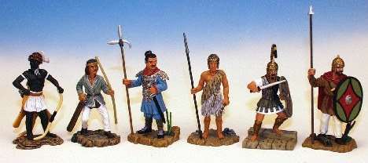  AC.6  Parthian Archer, Chinese Warrior, Numbian Warrior, Sumerian Archer, Trojan Warrior, Phoenician Warrior - $77

