Frontline Figures - Mounted Knights - 1 to 20
(http://www.frontline-figures.com)

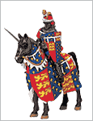  1  Black Prince, XIV | 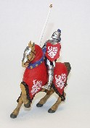  Sold Out  2  German Knight, XV | 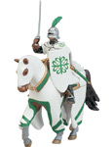  Sold Out  3  Order of Alcatara, XV | Sold Out  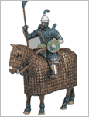  4  Kilbanoforos, XIII | Sold Out  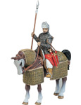  5  Abaside, XIII
Sold Out  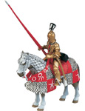  6  Italian Knight, XV | 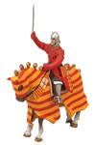  7  Aragonese, XIII | 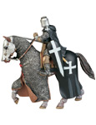  8  Hospitaller Knight, XIII | 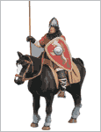  9  Norman Knight, X | 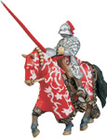  10  Maximillian Knight, XVI
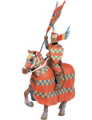  11  German Knight, XV | Sold Out  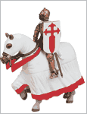  12  Order of Santiago, XV | 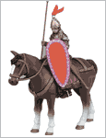  Sold Out  13  Boyar Knight, XIII | 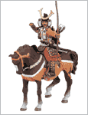  14  Samurai, XIV | 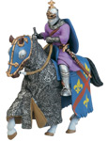  15  Portuguese Knight, XIV
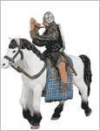  16  Pict, VIII | Sold Out  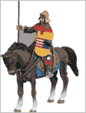  17  Hungarian, XIII | 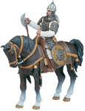  Sold Out  18  Mameluke, XIII | Sold Out  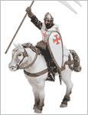  19  Templar, XII | 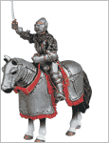  20  Lombard, XIV

